Name: |  | Class:
Centre Number: |  | Index Number:

DUNMAN HIGH SCHOOL
PRELIMINARY EXAMINATION
Year 6

______________________________________________________________________________

HIGHER 1 GEOGRAPHY 8834/ 01

Paper 1

INSERT
______________________________________________________________________________

READ THESE INSTRUCTIONS FIRST

This Insert contains all the Resources referred to in the questions.

_____________________________________________________________________________________

This document consists of 10 printed pages.
[Turn over

Resource 1 for Question 1

Map of Boston Chinatown showing Sites A, B, C and D and heat-relief facilities
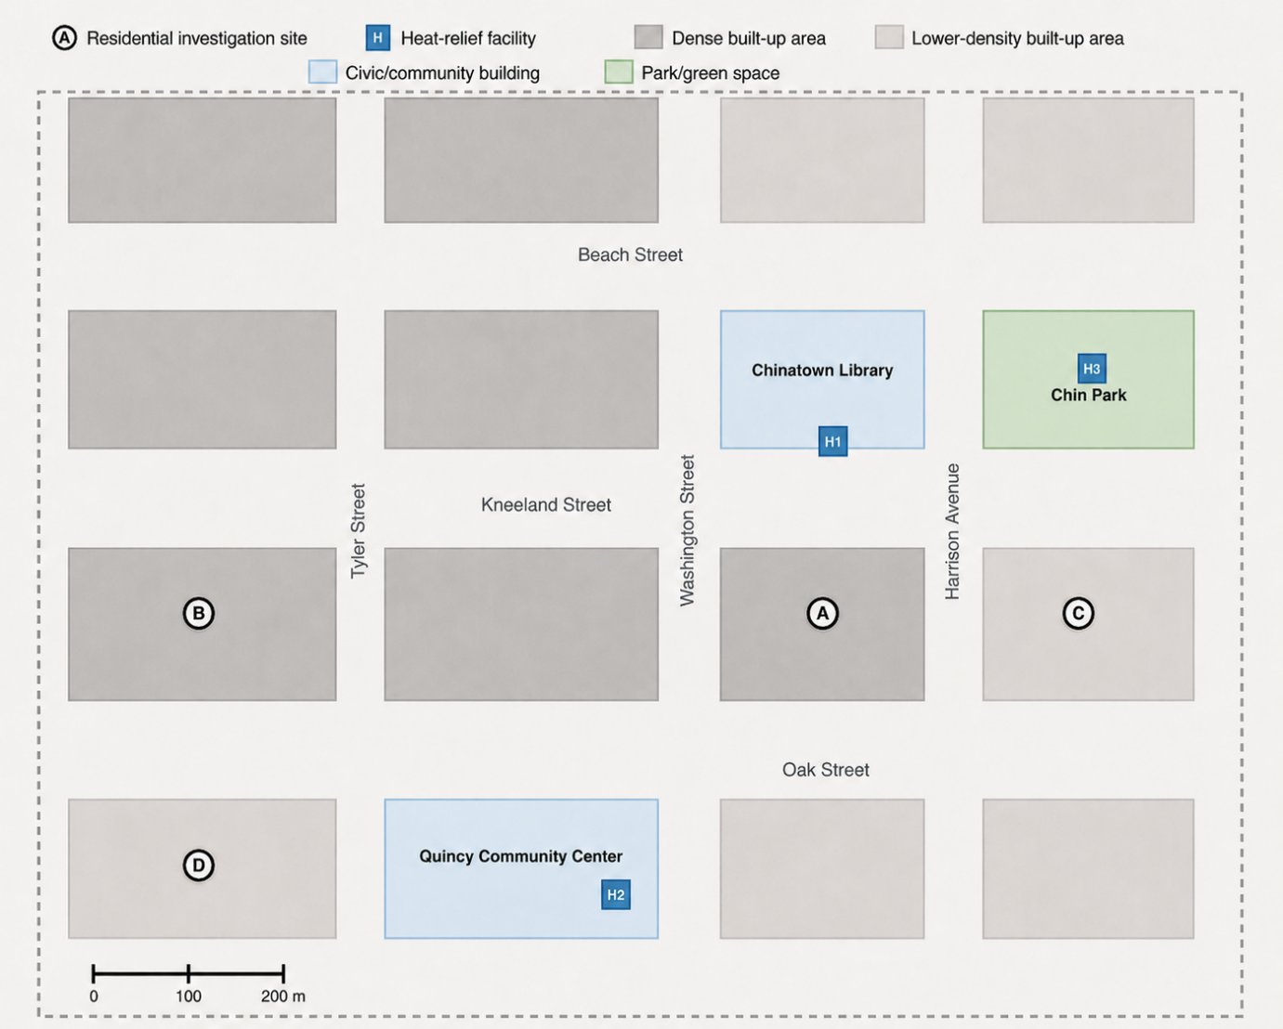

Resource 2 for Question 1

Age profile of respondents and
Boston Chinatown resident population

Age group | No of respondents | Boston Chinatown  resident population (%)
21–39 | 9 | 44.5
40–64 | 13 | 37.4
65 and above | 18 | 18.1

Resource 3 for Question 1

Findings of the investigation at Sites A, B, C and D

Site | Air temperature (°C) | Shade cover  (%) | Walking time to nearest heat-relief facility (min) | Respondents reporting access as ‘very easy’ or ‘fairly easy’ (%)
A | 35.2 | 15 | 3 | 82
B | 34.8 | 10 | 11 | 38
C | 31.6 | 55 | 4 | 76
D | 32.3 | 45 | 8 | 55

Resource 4 for Question 2

Maximum continental and sea ice cover in the Northern Hemisphere during the Last Glacial Maximum* and today

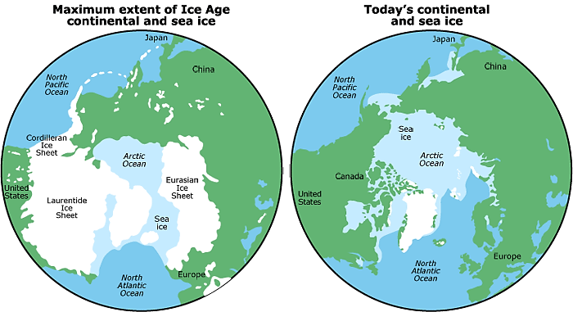
Last Glacial Maximum
Today
Greenland Ice Sheet
Greenland Ice Sheet

Key

sea ice

continental ice sheet

ocean

land

*Last Glacial Maximum refers to the most recent glacial period that took place between 26,000-19,000 years ago.

Resource 5 for Question 2

Projected percentage change in Gross Domestic Product per capita (GDP per capita)** in countries due to climate change
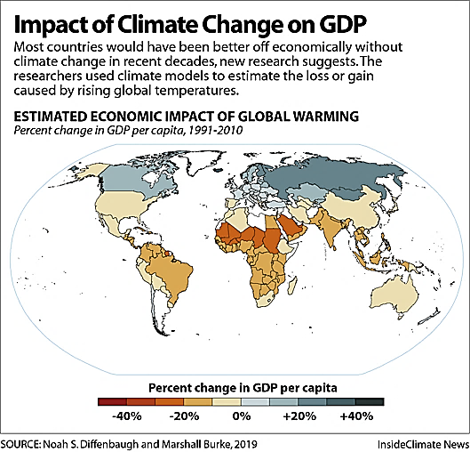

equator

No data
Key
– 40%
– 20%
0%
+20%
+40%

**Gross Domestic Product per capita refers to the total value of all goods and services produced within a country divided by the number of citizens.

Resource 6 for Question 2

Map of countries with ocean pH*** monitoring equipment

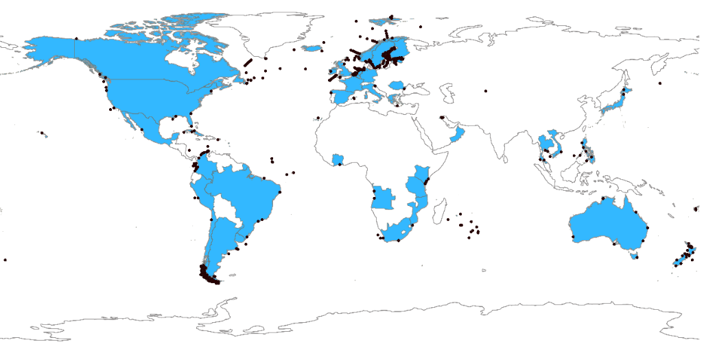
Key

ocean pH monitoring site

countries with ocean pH monitoring equipment
Atlantic Ocean
Pacific Ocean
Indian Ocean
Southern Ocean
Pacific Ocean

***pH is a measure of the acidity or alkalinity of a solution.

Resource 7 for Question 3

Percentage of population living in urban areas

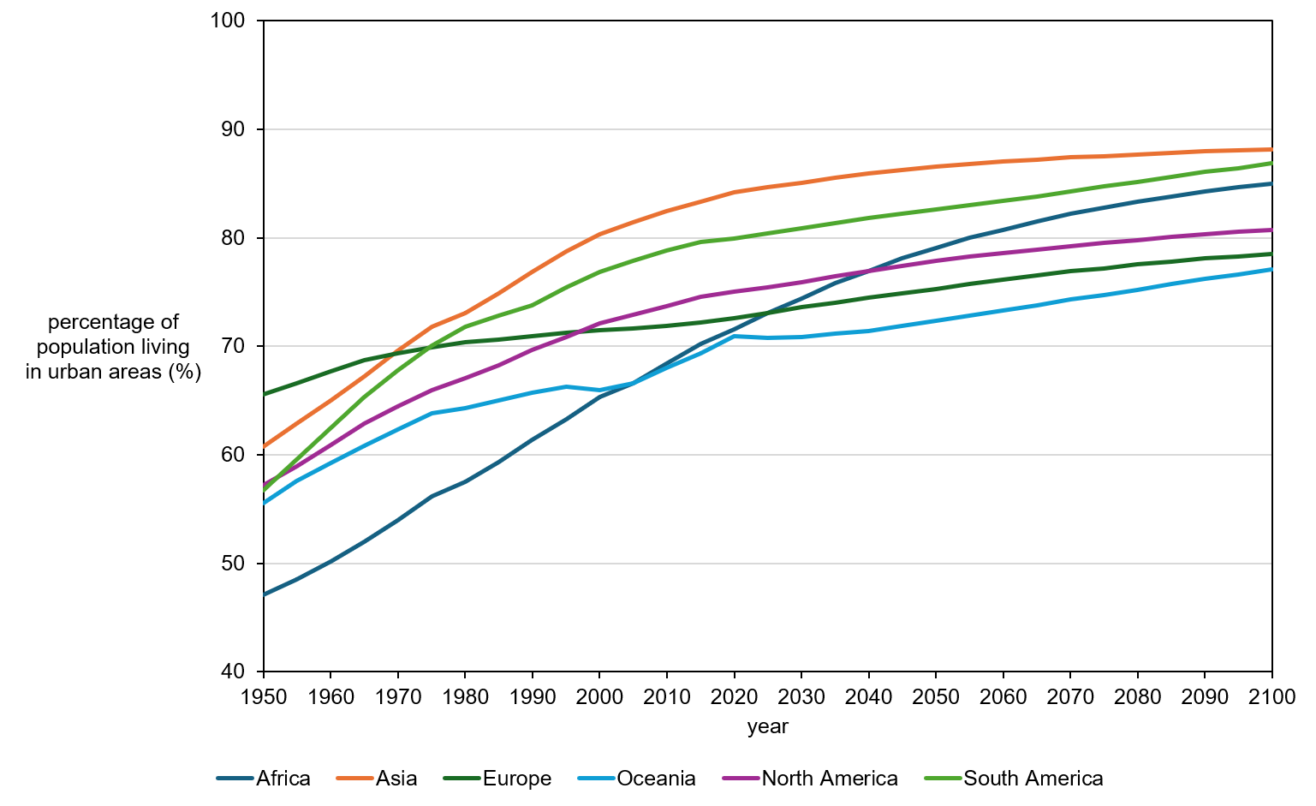
South America
Asia
Africa
Europe
North America
Oceania

Resource 8 for Question 3

Percentage change in size of urban area and population density
in selected Indian cities from 2005 to 2020

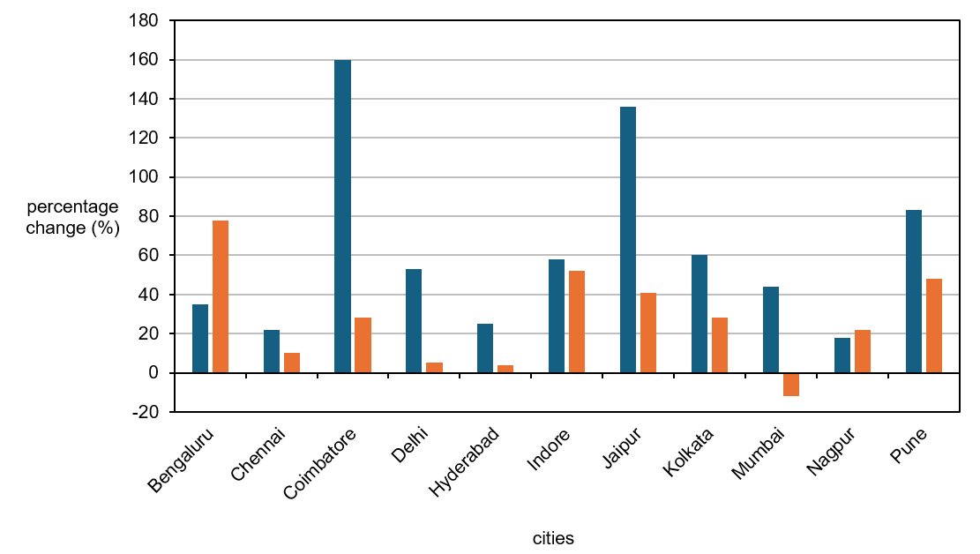
Key

size of urban area

population density

Resource 9 for Question 3

A slum in Delhi, India

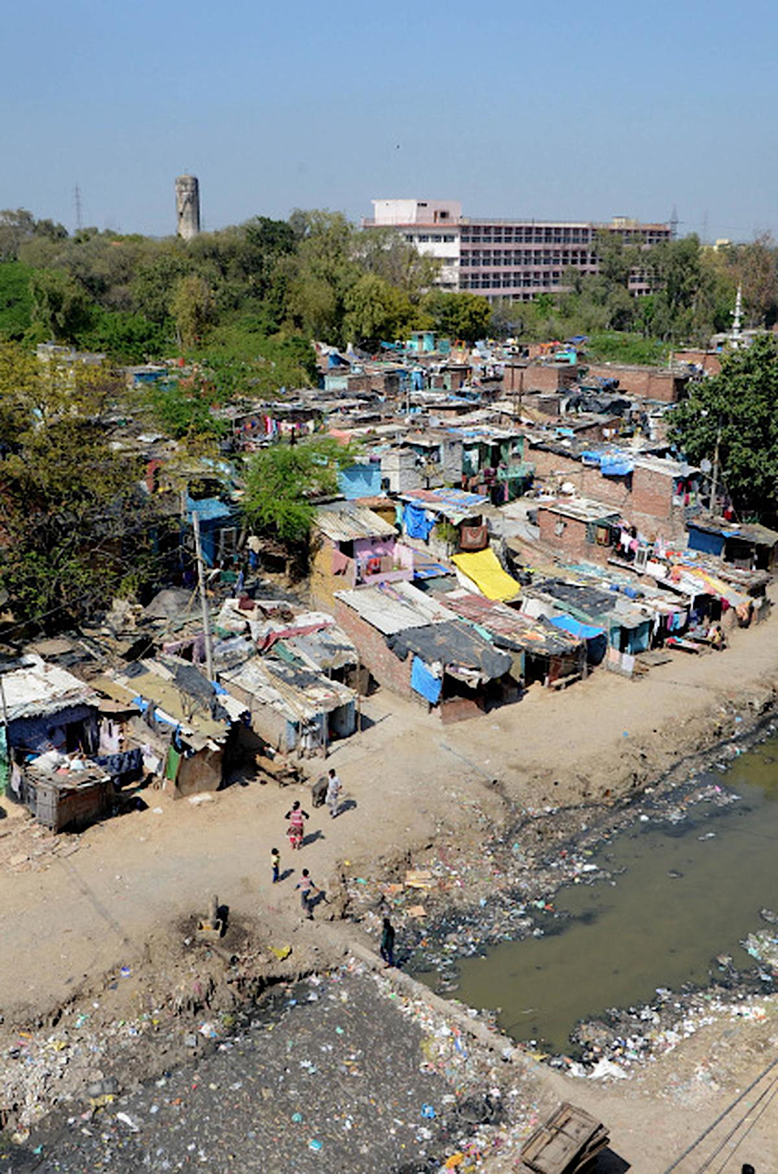

Resource 10 for Question 3

Percentage of slum houses with selected features before and after redevelopment in Delhi, India

feature | percentage of slum houses  with feature
feature | before redevelopment | after redevelopment
sanitation facility at home | 22% | 87%
piped water at home | 19% | 65%
cooking in a separate kitchen,  instead of in the bedroom | 19% | 59%

______________________________________________________________________________________________

Copyright Acknowledgements

Question 1 | Resource 1 | © Schematic map based loosely on Boston Chinatown and created by the question setter for assessment purposes. Locations and spatial relationships are simplified.
 | Resource 2 | © U.S. Census Bureau, 2010 Census, Boston Redevelopment Authority Research Division analysis.
Question 2 | Resource 4 | © https://earthscience.stackexchange.com/questions/24265/why-was-the-ice-age-more-severe-in-north-america-than-in-eurasia
 | Resource 5 | © https://insideclimatenews.org/infographics/chart-impact-climate-change-gdp/
 | Resource 6 | © World Meteorological Organisation (2024) State of the global climate 2023.
Question 3 | Resource 7 | © European Commission, Joint Research Centre (JRC) (2025) – with major processing by Our World in Data. “Share of population living in urban areas – DEGURBA” [dataset]. European Commission, Joint Research Centre (JRC), “Global Human Settlement Layer Dataset” [original data].
 | Resource 8 | © Mukherjee, A., Panda, J. A study on the urban growth and dynamics over 16 major cities of India. Journal of Earth System Science 133, 66 (2024).
 | Resource 9 | ©https://images.hindustantimes.com/rf/image_size_800x600/HT/p2/2016/06/06/Pictures/following-burmaula-hindustan-construct-residents-prepared-estimate_ea481394-2be4-11e6-9019-0e3372d9e70b.jpg
 | Resource 10 | © Bag, S., Seth, S., & Gupta, A. (2016). A comparative study of living conditions in slums of three metro cities in India. Leeds University Business School Working Paper, (16-07).

